Quasars and Cosmology, Exam #2, Fall 2005 Name ______________________________

Part I – Multiple Choice (3 pts each) – Choose the best answer from the choices given.

______ 1. Which of the following is not a type of active galaxy?
- Blazar
- Seyfert
- Quasar
- Cepheid

______ 2. The type of active galaxy we observe depends on:
- The viewing angle and the rate of accretion
- The viewing angle and the mass of the central black hole
- The mass of the central black hole and the rate of accretion
- None of the above

______ 3. The speed of material in a quasar jet is approximately:
- 0.1 times the speed of light
- 0.5 times the speed of light
- 0.99 times the speed of light
- 6.0 times the speed of light

______ 4. Material spirals into the central black hole of an AGN from the
- accretion disk
- broad line region
- torus
- narrow line region

______ 5. Over time, active galaxies will evolve to become:
- blazars
- normal galaxies
- galaxy clusters
- wormholes

______ 6. If a galaxy is moving away from us, the Doppler shift will cause the atomic lines in the spectrum to be shifted:
- to the blue (shorter wavelengths)
- to the red (shorter wavelengths)
- to the blue (longer wavelengths)
- to the red (longer wavelengths)

______ 7. If space expands, the atomic lines in distant galaxy spectra will be shifted:
- to the blue (shorter wavelengths)
- to the red (shorter wavelengths)
- to the blue (longer wavelengths)
- to the red (longer wavelengths)

______ 8. Which of the following is used to measure the distances to galaxies outside the Milky Way?
- Bouncing radar waves off of the galaxy’s gas
- Comparing our measured brightnesses to the intrinsic brightness of variable stars in the galaxy
- Measuring the speed of the jet from the galaxy’s central black hole
- Inferring the look-back time from the ages of the stellar populations in the galaxy

______ 9. Parallax is:
- The apparent change of position of a nearby star with respect to background stars, due to the motion of the Earth around the Sun
- The apparent change of position of a nearby star with respect to background stars, due to the rotation of the Earth on its axis
- The apparent change of position of a nearby star due to gravitational lensing by the Sun
- Any apparent change of position of a nearby star

______ 10. By showing that more distant galaxies were receding more quickly than closer ones, Hubble showed that:
- The Universe was expanding
- The Universe was accelerating
- The Universe was homogeneous
- The Universe was isotropic

______ 11. Which of the following are composed primarily of baryonic matter:
- people, planets, and stars
- planets, stars, and galaxies
- gas, dust, and dark matter
- everything in the Universe is composed of primarily baryonic matter

______ 12. The most common element in the Universe is:
- hydrogen
- helium
- carbon
- nitrogen

______ 13. A galaxy’s peculiar velocity is:
- the speed the galaxy appears to be moving due to the expansion of the Univserse
- the speed the galaxy is moving through the expanding Univsere
- the component of the speed of the galaxy tangential to our line of sight
- the velocity inferred from the galaxy’s redshift

______ 14. The source of the cosmic microwave background is:
- light that was present in the Universe when electrons and protons combined to form atoms
- light emitted in jets of active galaxies
- light emitted when the first stars formed in the early Universe
- light emitted by ancient civilizations in our backward light cone that is just reaching us today

______ 15. Einstein formulated a theory of gravity in which:
- F=ma
- Mass warps space
- Space and time are indistinguishable
- Dark matter does not exist

______ 16. Einstein added an ad hoc term to his equations of gravity, containing an unknown constant λ, which represented:
- the (unknown) mass density of dark matter
- the relationship between distance and velocity
- an unknown force or pressure that held the Universe apart against the pull of gravity
- the strength of the cosmic microwave background

______ 17. Which of the following is a true statement about our Universe?
(a) The galaxies are flying apart into empty space at the edges of the Universe.
(b) The Universe looks like a balloon.
(c) In the past, the scale length of the Universe was smaller than it is today.
(d) The average mass density of the Universe is negative.

______ 18. The Hubble constant, H₀, measures:
- The relationship between a galaxy’s redshift and its distance at the present time.
- The average mass density of the Universe at the present time.
- The relationship between a galaxy’s redshift and its distance as a function of time.
- The average mass density of the Universe as a function of time.

______ 19. Results from observations of Type Ia supernove indicate that in the future the expansion rate of the Universe will
- fluctuate
- increase
- decrease
- remain the same

______ 20. Type Ia supernovae, at their brightest, are about as bright as:
- the Sun
- a globular cluster
- a galaxy
- a cluster of galaxies

______ 21. The average density of matter in the Universe is equivalent to the density of:
- 2 hydrogen atoms per cubic meter
- 2 electrons per cubic meter
- 2 golf balls per cubic meter
- 2 loaves of bread per cubic meter

______ 22. If the measurement of the Hubble constant is cut in half, our inferred age of the Univserse is:
- ¼ as large
- ½ as large
- twice as large
- unchanged

______ 23. A certain galaxy is 30 kpc in diameter and 33 Mpc away from us. There are 1000 kpc in 1 Mpc. What angular size do we measure for the galaxy?
- 0.0009 radians
- 0.009 radians
- 0.09 radians
- 0.9 radians

______ 24. On the surface of a balloon, the sum of the interior angles of a triangle is:
- less than 180°
- equal to 180°
- greater than 180°
- could be any of the above

______ 25. Which of the following is a true statement regarding the center of the Universe?
- There is no center of the Universe in 3-dimensional space.
- Our galaxy is located at the center of the Universe.
- The center of the Universe contains the largest black hole.
- We are still searching for the center of the Universe.

______ 26. If R(t) is the scale factor in our Universe, and R(t) = R/R₀, then what is the current value of R(t) in our Universe?
- -1
- 0
- 1
- it cannot be calculated

______ 27. If the scale factor in our Universe increased by a factor of 2, then the average distance between galaxies would
- decrease by a factor of 8
- decrease by a factor of 2
- increase by a factor of 2
- increase by a factor of 8

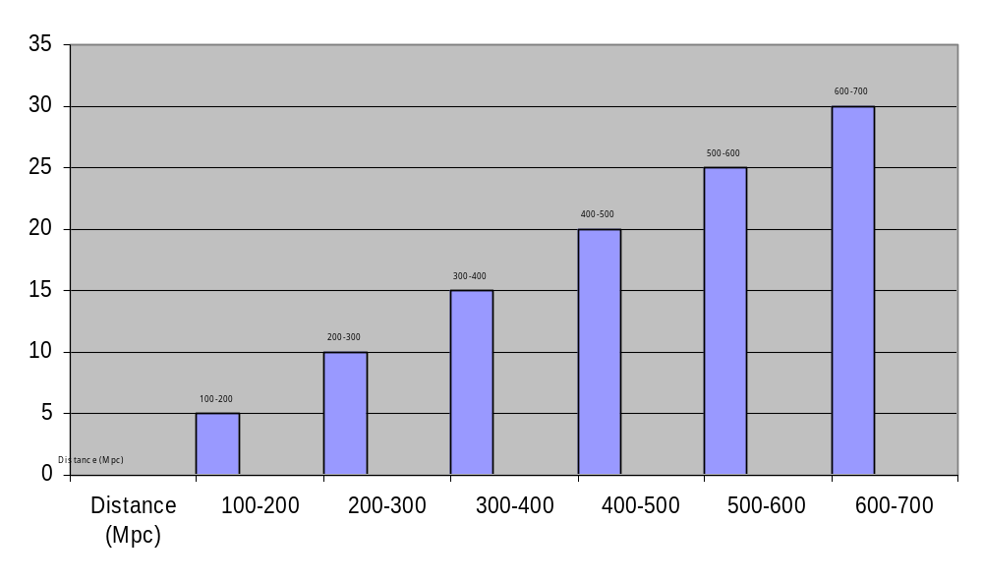
This plot shows the number of galaxies observed in a small area of the sky as a function of distance, from an Earth-like planet in some Universe with two spatial dimensions.

______ 28. The plot above could be evidence that space in that Universe:
- has positive curvature (like a balloon)
- is flat (like a piece of paper)
- has negative curvature (like a saddle)
- is four dimensional

Part II – Definitions (4 pts each)

Space-time diagram –

Cosmological Constant (Λ) –

Part III - Short Essay (8 pts)

Answer in complete sentences. The minimum number of sentences to get full credit is four. Compound sentences could count as more than one sentence. Equations or graphs can count as sentences. Credit will be added for correct and informative sentences. Credit will be subtracted for sentences with incorrect information. No credit will be assigned for repeated or irrelevant sentences.

What is the Hubble constant, and how can we measure it?

